Create a simple script file , with some data present it and push it to repo. Now Create a project in Jenkins connected to your GitHub repository. When a commit is made to your repo, automatically build must get triggered from Jenkins and the output must be shared to me via email.

Cloned scripts to my Repo

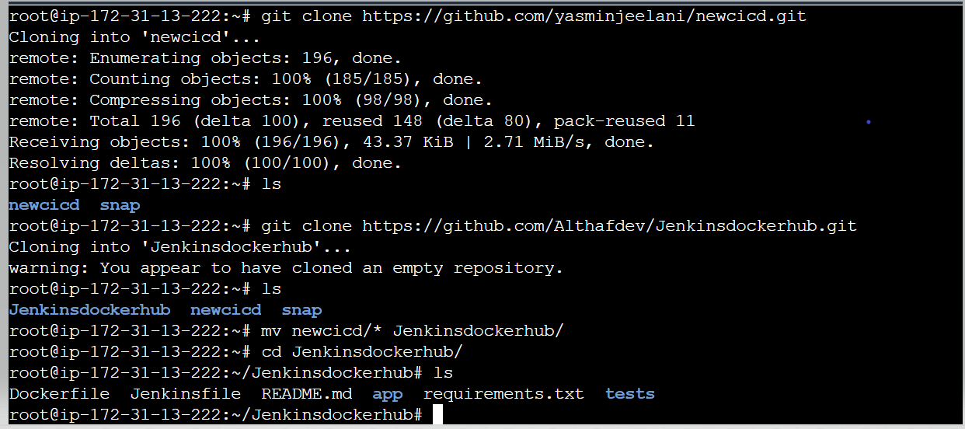

Files Pushed to my Repo

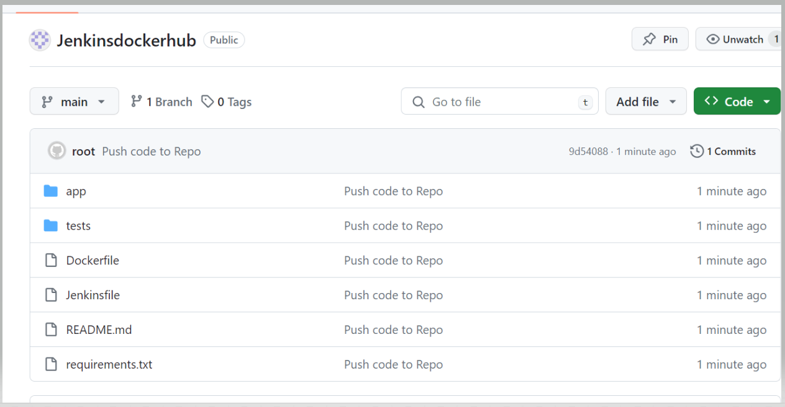

Installed and updated ubuntu, Docker and jenkins..Provided the admin level access, restarted the jenkins

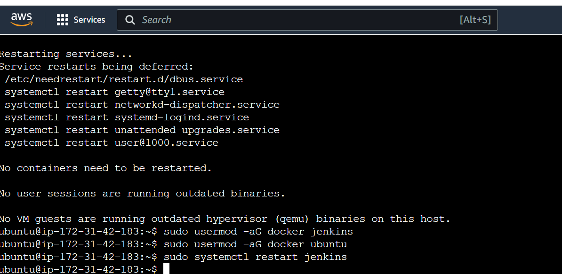

Created a project “Jenkins CICD” for to push the docker image in docker hub using Jenkins CICD

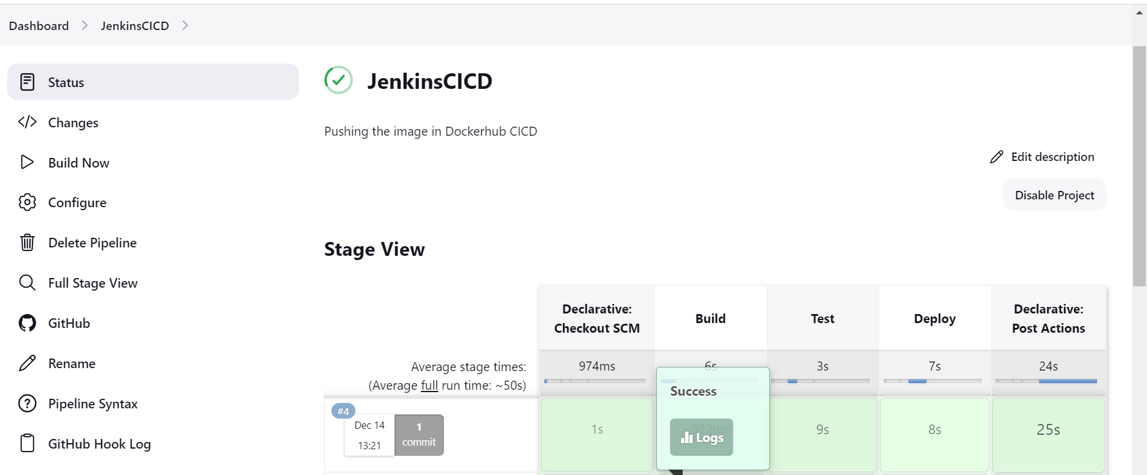

Build happened automatically whenever the code is pushed using Webhook

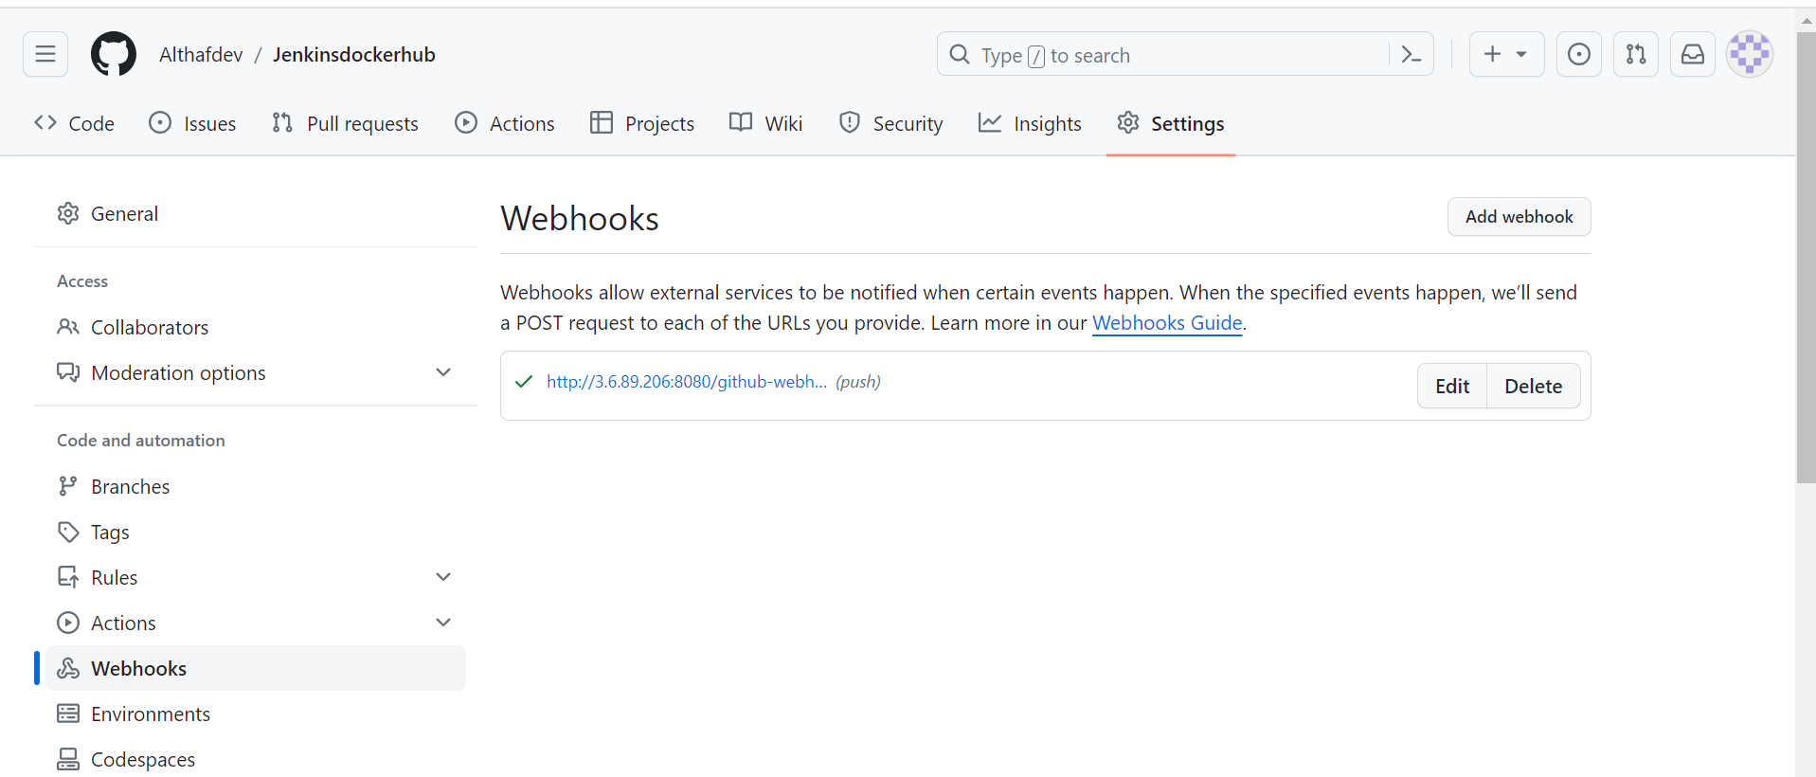

Output

Docker Image is pushed in my Docker Hub repository

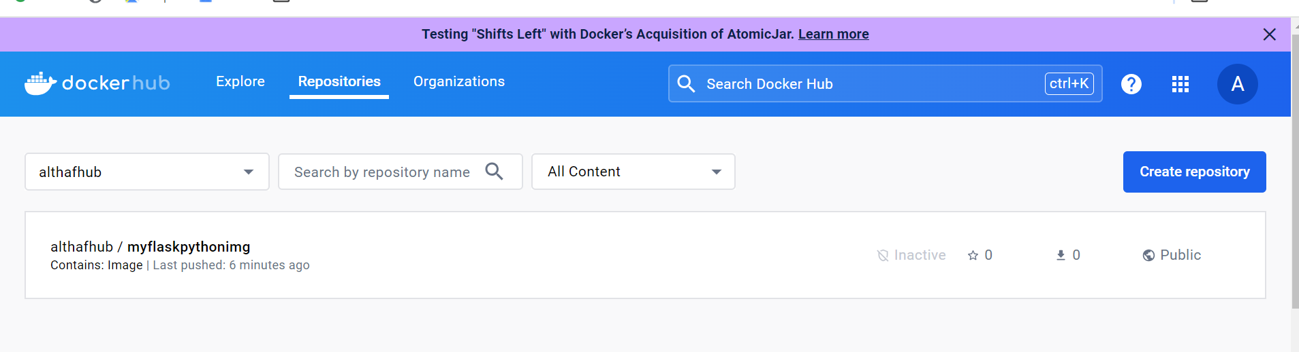

Test Email

